Do not make a separate cover, but fill in the box below with the assignment number and title, department, student ID, name and submission date. Delete this phrase when printing. If you make a separate cover, you will be deducted 10% from the total score.

HW3. DataLab

Department Name: Your Department
2018-12345 (Your student number)
Your name
Submission date: 2019-10-??

The report should include the following:

Problem Definition (20 points)

1) Goal
- Identify and describe the primary goals in this homework 3

2) Requirements and Problem Analysis
- Rewrite in your own words the desired requirements and issues in the assignment. (20% deduction from the total score if you copy the contents of the task as it is)

Design of the Program (30 points)

For each problem of DataLab, provide Pseudocode of your program design
- Pseudocode is not actual c codes. It present key ideas how to solve problems

Program Execution (20 points)
(1) Types of operating systems and compilers used
(2) How to compile and execute the program
(3) Include a screen capture for illustrating how the program works
(4) Include a screen capture showing your scores by executing your program. If you no dot insert this capture, you will get only 30 points.
Example screen shots:
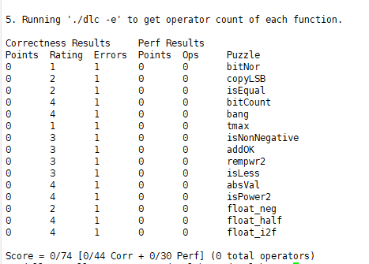

Github repository (20 points)
(1) include github commands for cloning, adding, committing and pushing
(2) After pushing the source code and the makefile to your github directory, include the screen capture image of the Github repository

Discussion (10 points)
- What you learned while doing your homework (contents other than class hours),
- Describe difficulties during homework

